
Name = Muhammad Daniyal
Registration no = 24371
Submitted to : Mam Faryal
Date : 15/06/2026

Software Construction and Development CA

Lab 11

Inheritance

Lab Tasks

Task 1:
- Add a display() function in the Student class.
- Move all cout statements into this function.
- Call the function from main().

Input/output:
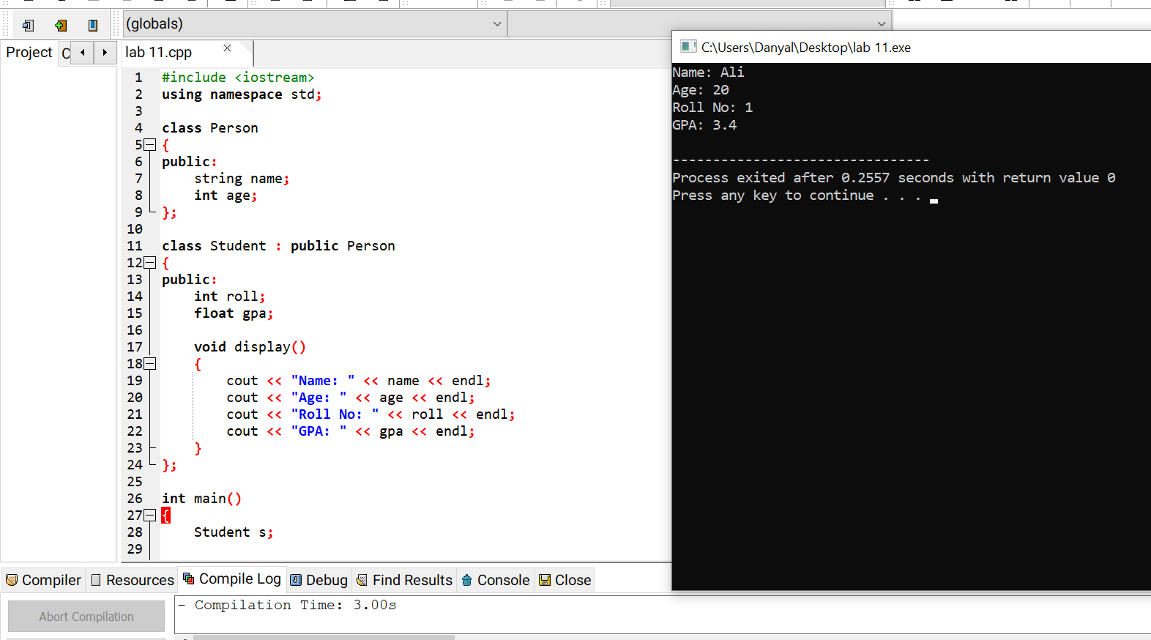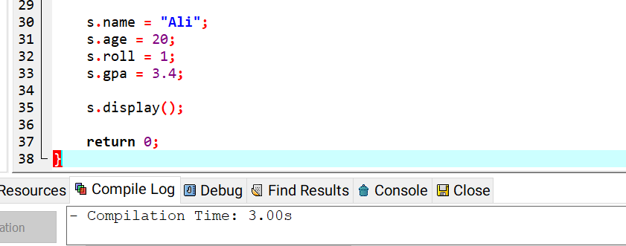

Task 2:
- Create a constructor in the Person class to initialize name and age.
- Use this constructor in the Student class.

Input/output:
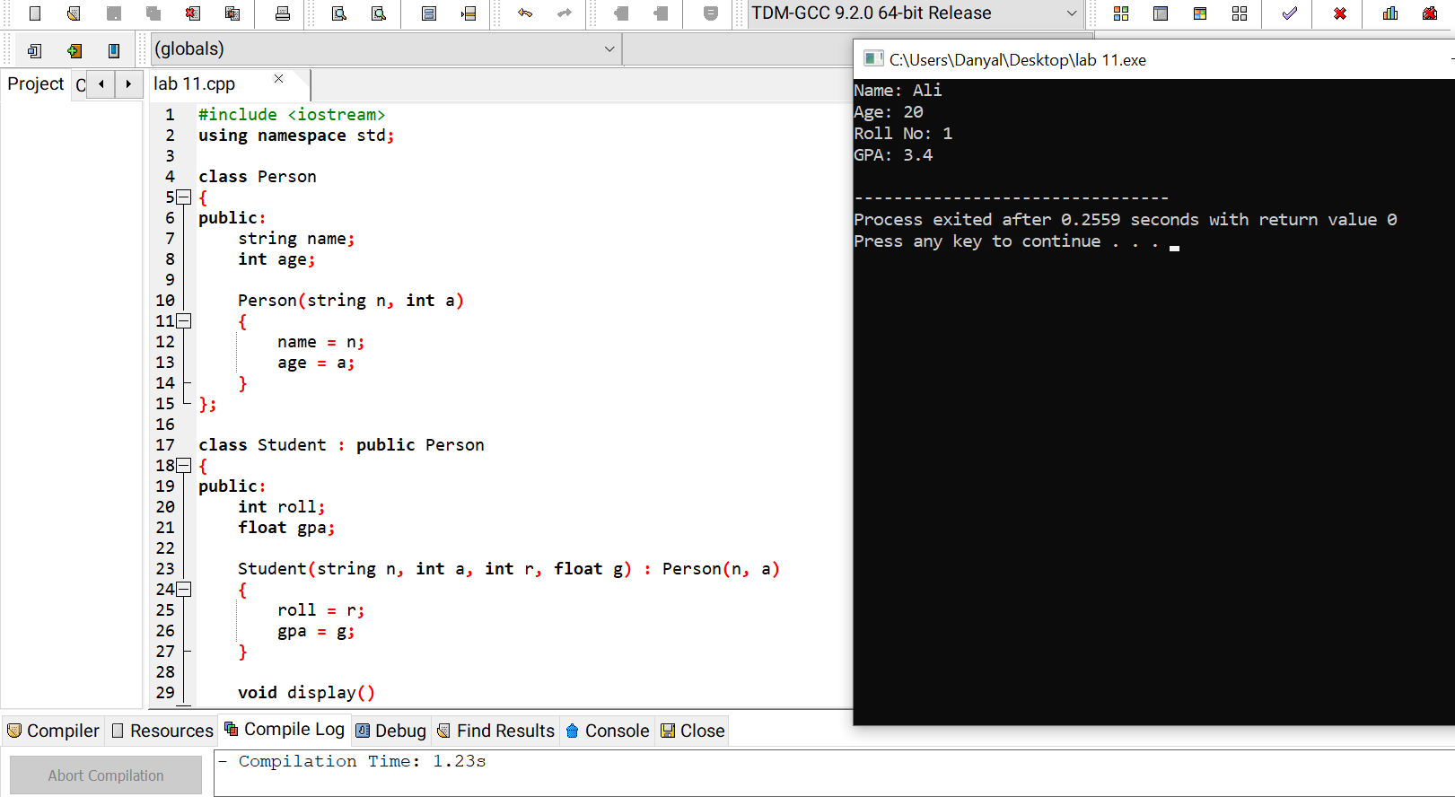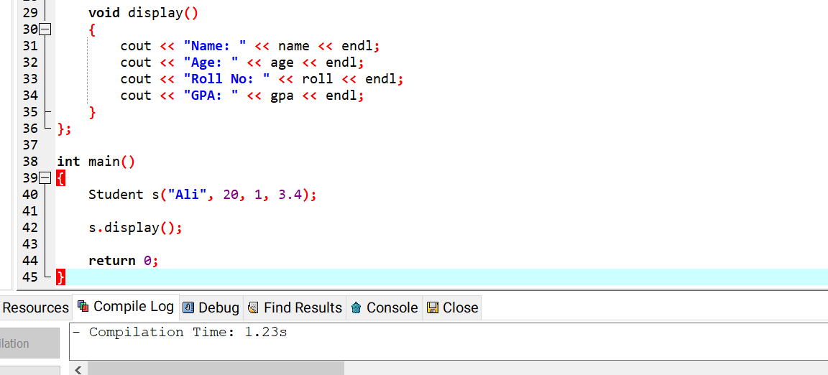

Task 3:
- Create a new derived class Teacher from Person.
- Add:
  - Subject
  - Salary
- Display teacher information.

Input/output:
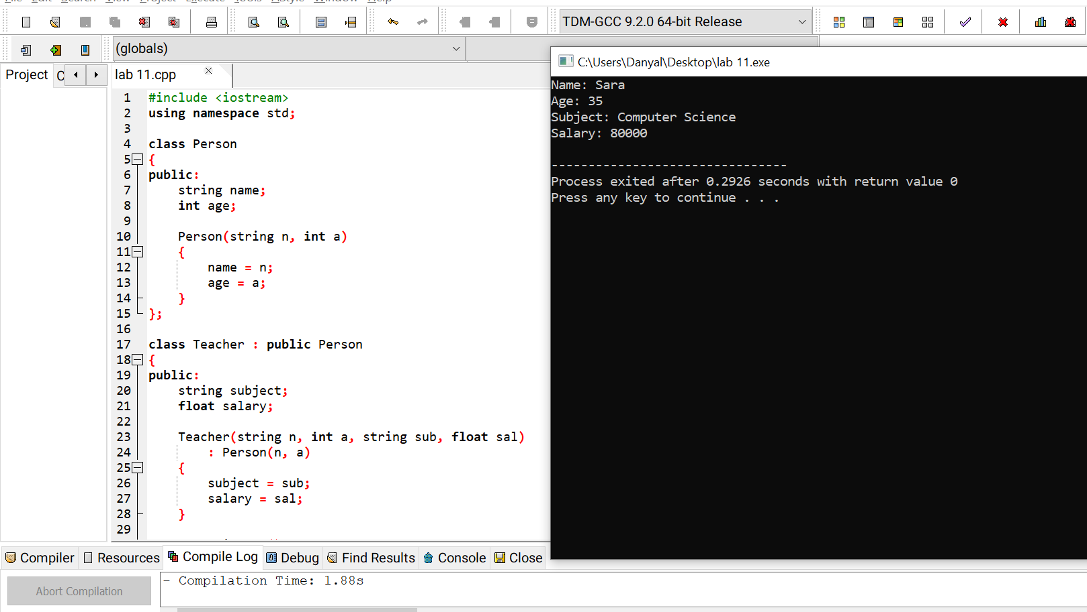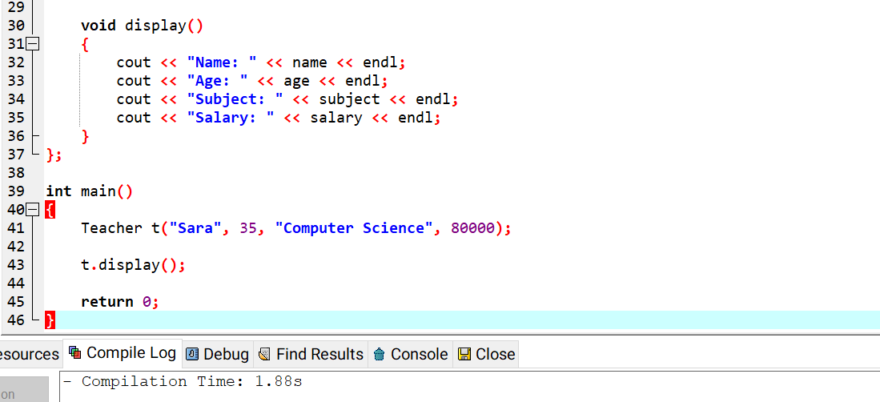

Task 4:
- Create at least two Student objects.
- Store and display data for both students.

GitHub Commands
git add lab11-inheritance.cpp
git commit -m "Lab 11 Inheritance" git push

Input/output:
